**SQL Assignment:**

**Tasks:**

1. Produce schema diagram.

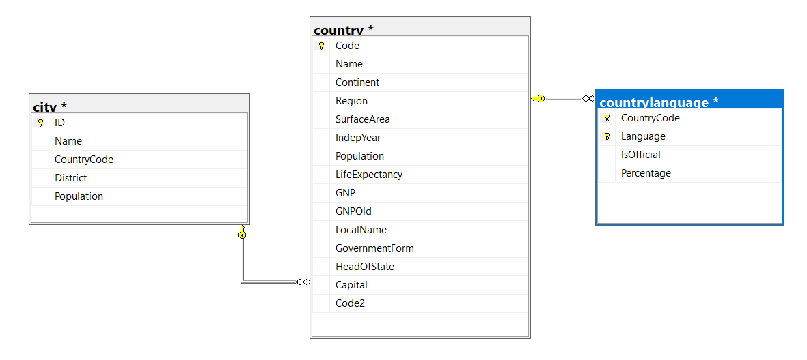

1. Using count, get the number of cities in the USA

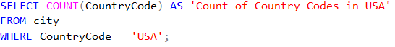

Result:



1. Find out what the population and average life expectancy for people in

Argentina (ARG) is



Result:



1. Using ORDER BY, LIMIT, what country has the highest life expectancy?

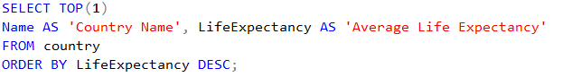

Result:



1. Select 25 cities around the world that start with the letter 'F' in a single SQL query.

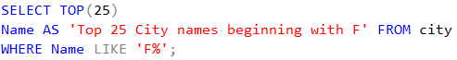

Result:



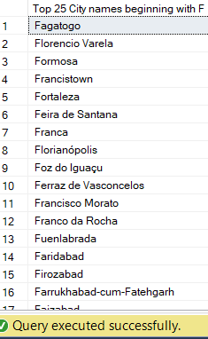

1. Create a SQL statement to display columns Id, Name, Population from the city table and limit results to first 10 rows only.



Result:

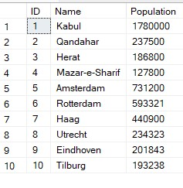

1. Create a SQL statement to find only those cities from city table whose population is larger than 2000000.



Result:



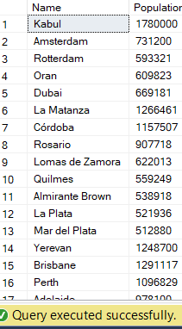

8. Create a SQL statement to find all city names from city table whose name begins with “Be” prefix.



Result:

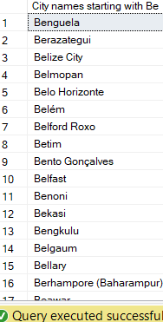

9. Create a SQL statement to find only those cities from city table whose population is between 500000-1000000.



Result:



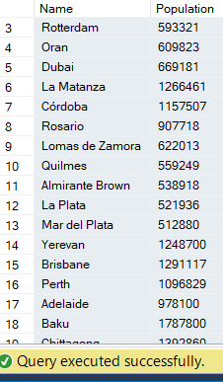

1. Using LEFT JOIN, ON, what is the capital of Spain (ESP)?

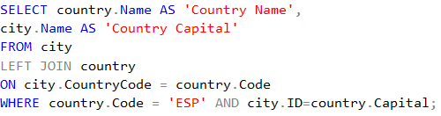

Result:



1. Using LEFT JOIN, ON, list all the languages spoken in the 'Southeast Asia' region

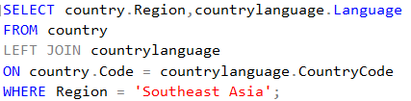

Result:



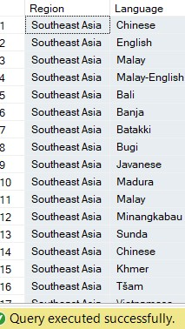

1. Create a SQL statement to find a city with the lowest population in the city table.



Result:

